Follow the instructions below to setup the OAK-D W PoE Camera for Windows with python:

- Connect the Oak camera using a PoE switch to your laptop.

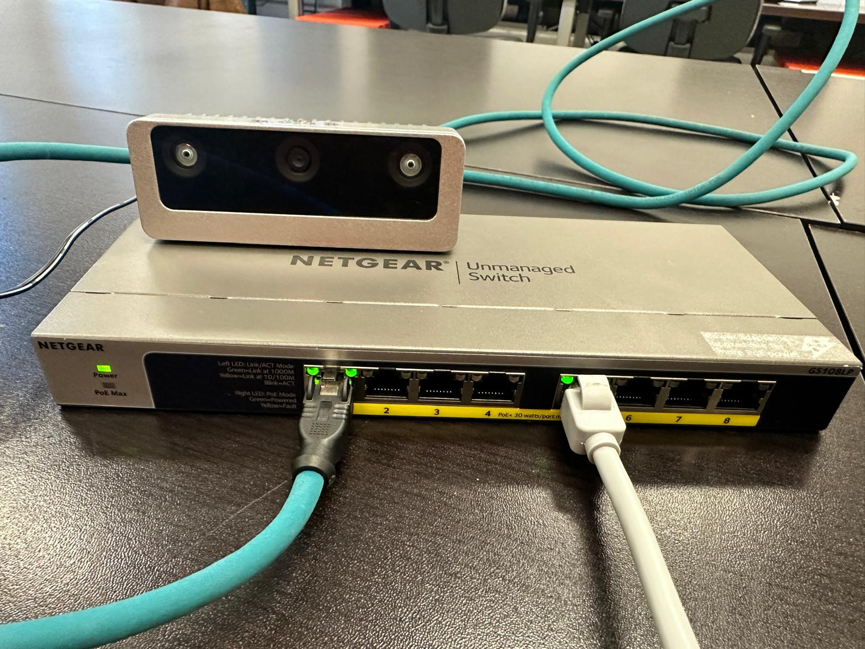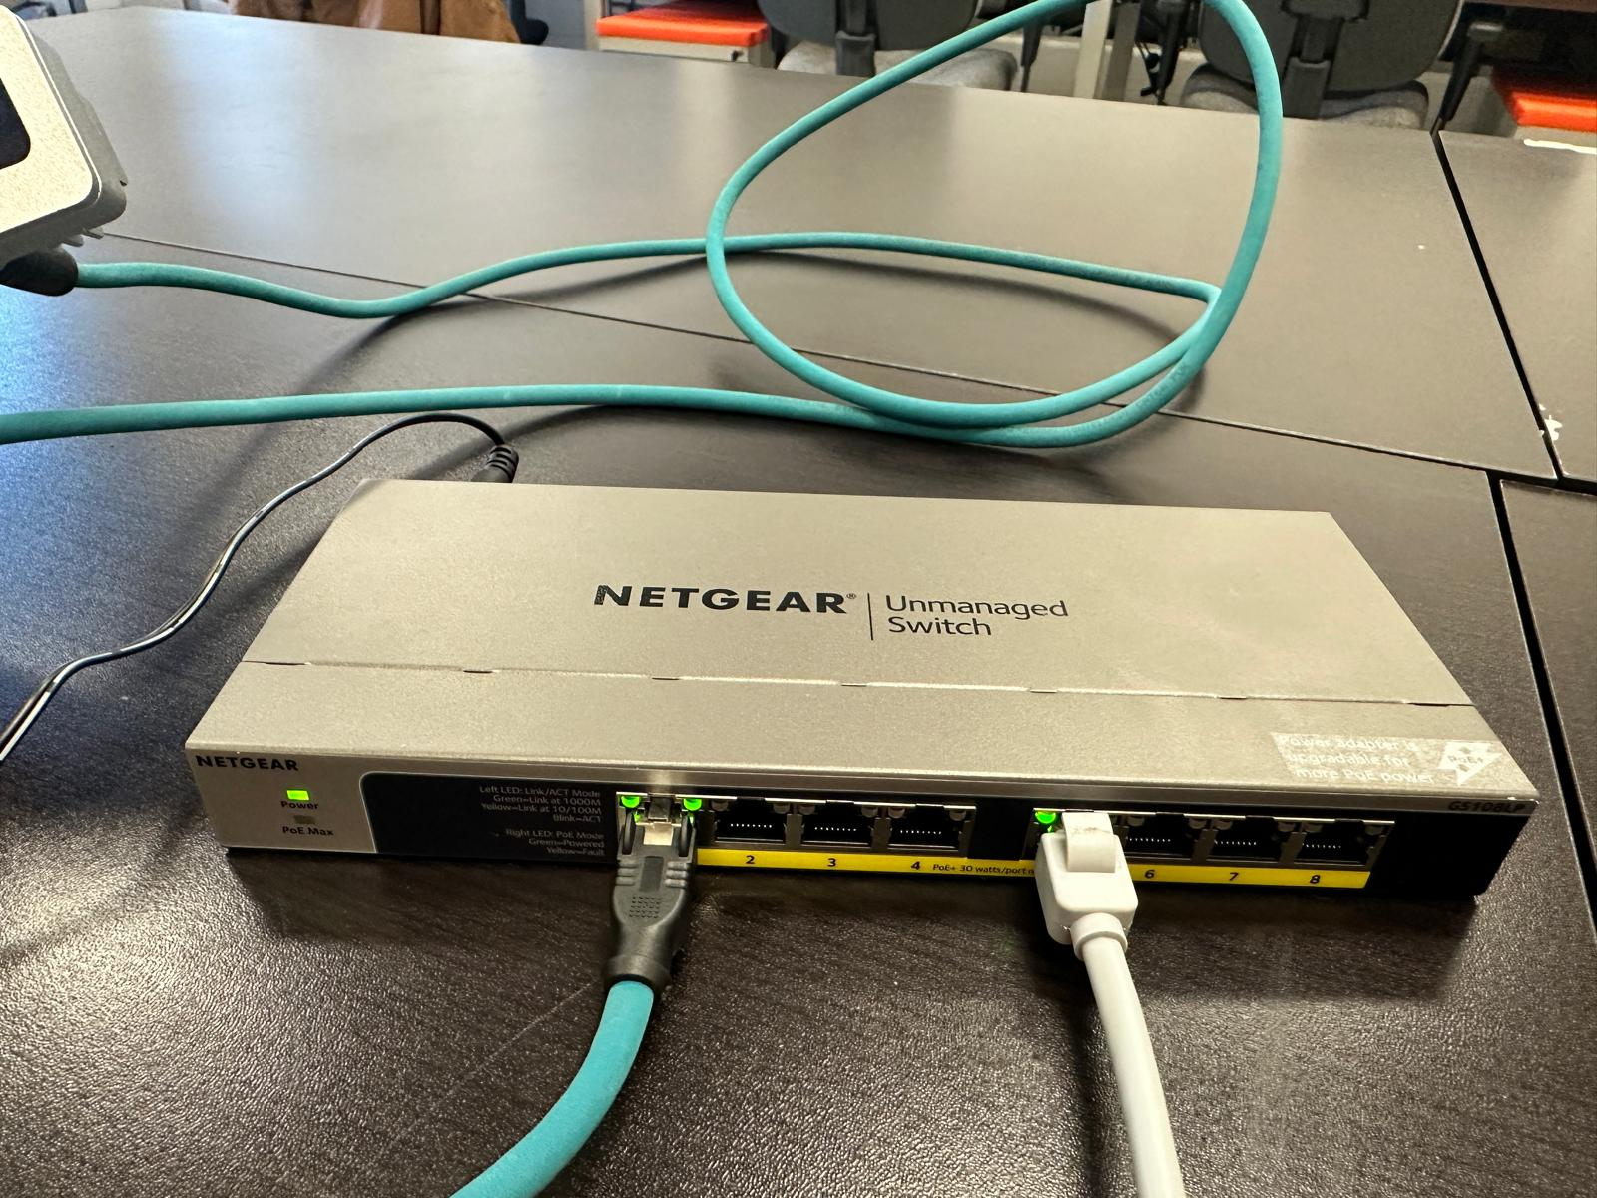

- Run “python3 -m pip install depthai” on the windows command prompt to install the packages for python depthai.
- Now, disconnect the internet connection (Wi-Fi) and then execute the below steps.
- Download the IP_Config.py script and before running the code make sure to disconnect the internet from your device to proceed further with changing the IP, gateway and subnet mask for the camera to connect. Press ‘1’ when the script is executed, then enter the IP address that is displayed when the code is executed when asked for “Enter IPv4”, enter ‘255.255.0.0’ for IPv4 mask and ‘0.0.0.0’ for IPv4 gateway. Lastly again enter ‘y’ for confirming all this information.
- To check once if the camera is connected to the laptop or not, before moving to the next step. Download the cameraCheck.py script and run it. After running the code if it prints an empty list then the camera is not connected to the laptop.
- Now execute the “python3 -m depthai_viewer” to launch the depthai viewer for the camera. After running this command, wait for a few seconds and then connect the internet again.

